Software Integration Plan of Diabetes Insulin Pump

Written by: Afzonia Khizar (i16-1058)
Reviewd by: Ifrah Qaiser & Ayesha Asif
Approved by: Rabeeba Ahmed

Table of Contents

1 Introduction 3
1.1 Purpose 3
1.2 Scope 3
1.3 Abbreviations and Glossary 3
1.3.1 Abbreviations 3
1.3.2 Glossary 3
1.4 Reference Document 4
2 Component Architecture Description 5
2.1 Syringe 6
2.2 Blood Sugar Sensor 6
2.3 Speaker 6
2.4 LCD Display 6
2.5 Control 6
2.6 Glucometer 6
2.7 Basal and Bolus Calculation 6
3 Integration Tests 8
3.1 Insulin Pump – Syringe 8
3.2 Insulin Pump – Blood Sugar Sensor 8
3.3 Insulin Pump –Controller 9
3.4 Insulin Pump – LCD Display 9
3.5 Insulin Pump – Speaker 9
4 Tools and Test Equipment Required 10
5 Program Stubs and Test Data Required 10
6 Responsibilities and Schedule 10
6.1 Roles and Responsibilities 10
6.2 Key Dependencies 10
6.3 Risks and Assumptions 10
6.4 Schedule 11

Introduction

Purpose
The purpose of the integration test plan is to describe the necessary tests to verify that all of the components of insulin pump are properly assembled. Integration testing ensures that the unit-tested modules interact correctly.

Scope
Insulin pump is a computerized device which is used to deliver basal and bolus doses of insulin to the diabetic patient. Insulin is injected to the body by this pump and it is worn outside the body. It consists of a small plastic cannula, or catheter which is connected to plastic tubing, that tube transports insulin from the pump reservoir to the body. Cannula is inserted in body with a small needle and after that needle is removed.

Insulin pump allows for different basal and bolus rates to be programmed. This depends upon age limit i.e if blood glucose level is high then dose of basal rate would be increased at that time and vice versa.
The objective of this application is to provide an ease to the people that they can easily get insulin by pressing a button rather than injecting insulin with a syringe.

Insulin pump is developed according to the medical device standard IEC 62304 by considering software safety classification. All components are assigned to the classes on the basis of their criticality level.

Abbreviations and Glossary

This section provides definitions for common terms used throughout the document. They are provided to help minimize ambiguity throughout the document.

Abbreviations

LCD: Liquid Crystal Display
Glucometer: Glucose Meter

Glossary

Software safety classification: according to severity level Class A, B and C is assigned to software modules.
Class A: no injury or damage to health is possible
Class B: non-serious injury is possible
Class C: death or serious injury is possible
Cannula: A thin tube inserted into the body for medication.

Reference Document

The following references are supplemental to the material found in this document:
# | Document Identifier | Document Title
[STD1] | ID_ST1 | IEC 62304- Medical Device Software

# | Document Identifier | Document Title
[STD2] | ID_ST2 | IEC 62304-Design Document of the System

# | Document Identifier | Document Title
[STD3] | ID_ST3 | Insulin Pump Overview

Component Architecture Description

The Insulin pump medical device system can be divided into several components. Listed below are the five components and a brief description of each component’s purpose.
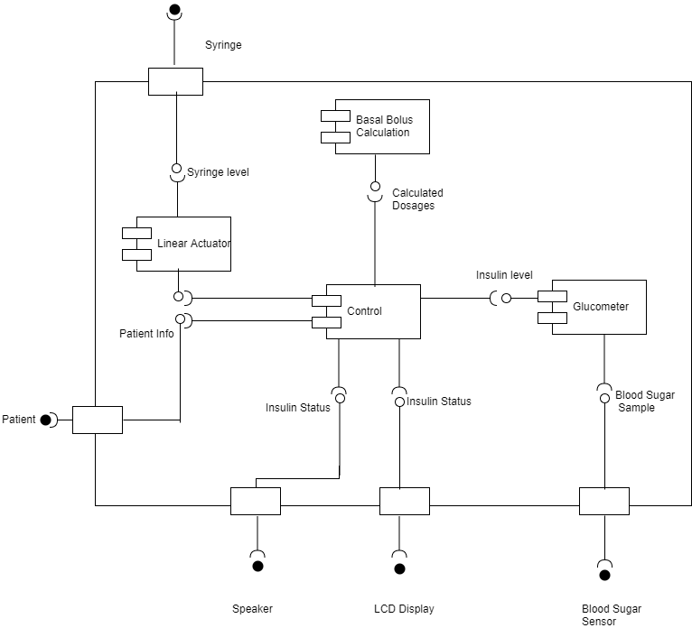
Figure 1 – Insulin Pump Component Diagram

Syringe
Syringe is necessary to inject the insulin in body by puncturing skin with a needle. It is attached with a cannula and after insertion and needle is removed from the skin but cannula stays inside the body.

Blood Sugar Sensor
Blood sugar sensor checks the glucose level from the tissue level as it is attached with a cannula. It starts working with a button pressing attached with insulin pump and transfers the information to the controller.

Speaker
It is important component of the system as it speaks when there is a critical situation, for example if blood sugar level is very low or very high. It notifies the user to inject the required dose by pressing a button.

LCD Display
It is the component of the system which displays the basal and bolus insulin information obtained from the sensor and displays the required amount of insulin information along with patient’s profile information.

Control
It is main component of the insulin pump system as it computes the required amount of insulin level after sensor sends information of basal and bolus insulin doses. It then sends the signal back to the pump to deliver the insulin to the body via reservoir. It also forwards the information to the display screen and speaker when needed.

Glucometer
Glucometer is also known as glucose meter and it measures the concentration of glucose in the blood after blood sugar sensor sense the glucose level from the body.

Basal and Bolus Calculation
Basal dose keeps blood sugar steady between meals (during fasting). It is also known as background insulin. Bolus dose is taken during meal times. Both insulin doses keep the blood sugar level under control.

Insulin pump is a safety critical system which as it can damage human’s health if it stops working or may not work properly. Insulin pump is developed according to the medical device standard IEC 62304 by considering software safety classification to make a reliable and safe medical device system. All components are assigned to the classes on the basis of their criticality level.

- Software safety class classification

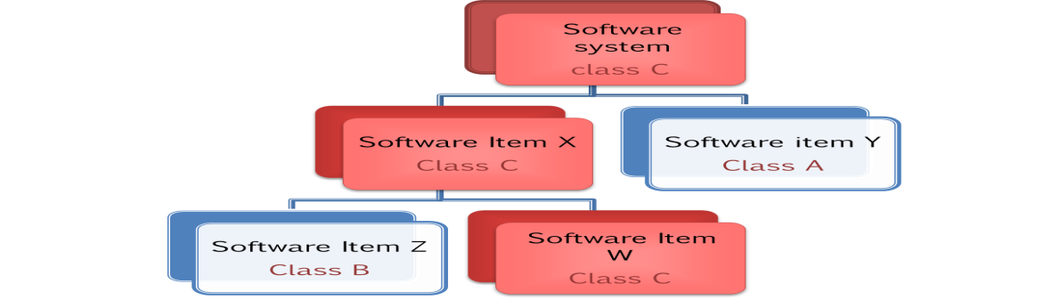

- Total number of classes:

No. | Name of class | Class A | Class B | Class C
1 | Basal Dose |  |  | X
2 | Bolus Dose |  |  | X
3 | Glucometer |  |  | X
4 | InsulinQueue |  | X
5 | Profile |  | X
6 | Speaker |  | X
7 | LCD |  | X
8 | StepperMotor |  |  | X
9 | Control | -- | -- | --

Integration Tests
This section details the black box tests needed to ensure that each component of insulin pump is interacting with other components as expected. These tests are important to ensure that insulin pump is working properly or not because a pump’s malfunction can cause immediate risks to the diabetic patient due to increase of blood sugar level.

Insulin Pump – Syringe
Purpose | The purpose of this test is to ensure that syringe injects the insulin in the body by puncturing skin with a needle.
External Dependencies | It is attached to the abdomen of the body along with a cannula.
Test Description | - It is attached with a cannula  - It is injected into the body with a cannula  - Syringe is removed after injecting into the body  - Cannula is attached with a body after removal of syringe
Expected Results | - It injects insulin  - cannula is attached with a body

Insulin Pump – Blood Sugar Sensor
Purpose | The purpose of this test is to ensure that sensor checks the glucose level from the tissue as it is attached with a cannula.
External Dependencies | Ensure that it is attached with a cannula.
Test Description | - It is connected with a cannula.  - It checks the basal insulin  - It checks the bolus insulin  - It sends insulin information to the controller
Expected Results | It checks the insulin amount in the blood sugar level and transfer that information to the controller

Insulin Pump –Controller
Purpose | The purpose of this test is to ensure that controller computes the required amount of insulin level after sensor sends information of basal and bolus insulin doses.
External Dependencies | None
Test Description | - It receives the basal and bolus insulin information from sensor  - It computes the required amount of insulin  - It sends back the signal to inject insulin into the body  - It forwards the information to the display  - It activates speaker
Expected Results | It computes the required amount of insulin and sends signals to the pump, display and speaker.

Insulin Pump – LCD Display

Purpose | The purpose of this test is to ensure that LCD displays the basal and bolus insulin information obtained from the sensor and displays the required amount of insulin information along with patient’s profile information.
External Dependencies | There is a user’s profile information in the system.
Test Description | - User pressed the button to start the insulin pump.  - LCD displays the user profile information  - LCD displays the insulin in blood sugar level  - LCD displays the required amount of insulin.
Expected Results | LCD displays all the information on pressing the button.

Insulin Pump – Speaker
Purpose | The purpose of this test is to ensure that speaker notifies the user to inject the required dose by pressing a button.
External Dependencies | Sound can be heard easily.
Test Description | - It receives signal from controller  - It speaks and notifies the user when blood sugar level is very high  - It speaks and notifies the user when blood sugar level is very low
Expected Results | It produces sound when blood sugar level is low or very high

Tools and Test Equipment Required

Insulin pump is a computerized device which requires hardware components to test the complete functionality. But its software part is tested in an integrated development environment (Visual Studio). It requires the aurdino to complete the functionality of sensor. Controller is the main class representing a separate component which performs the major working of insulin pump system. All other classes are associated with it.

Program Stubs and Test Data Required
Basal and Bolus calculation is required for each step as basal dose keeps blood sugar steady between meals (during fasting) and bolus dose is taken during meal times. Both insulin doses keep the blood sugar level under control. They are calculated on a controlled time period, for example if it is started with overnight then it is adjusted by our wake up time.

Responsibilities and Schedule

Roles and Responsibilities
Following are roles and responsibilities divided among the project members.

- Unit testing is performed by the manufacturer (Ifrah Qaiser and Rabeeba Ahmed )
- Integration testing is performed by the tester (Afzonia Khizar)
- Integration plan is reviewed by the Reviewer on the basis of complete system (Ayesha Asif)

Key Dependencies

An insulin reservoir is required which is long plastic tubing attached with a cannula to connect the insulin pump to the body

Risks and Assumptions
Different risks are associated with this medical device system as it can cause damage to user’s health if it may not work properly, for example
- Sensor stops working
- Cannula is not tightly attached to the body
- Air in the reservoir tube
- Speaker malfunction
- Controller stops sending signals to the pump

Schedule
- Unit testing is performed at each completion of units on the basis of requirements stated in requirements documents.
- Integration testing is performed after each new unit along with existing units.
- At the end, complete system is tested with all components.

